Instructions for Running the Time Series Application

June 2022

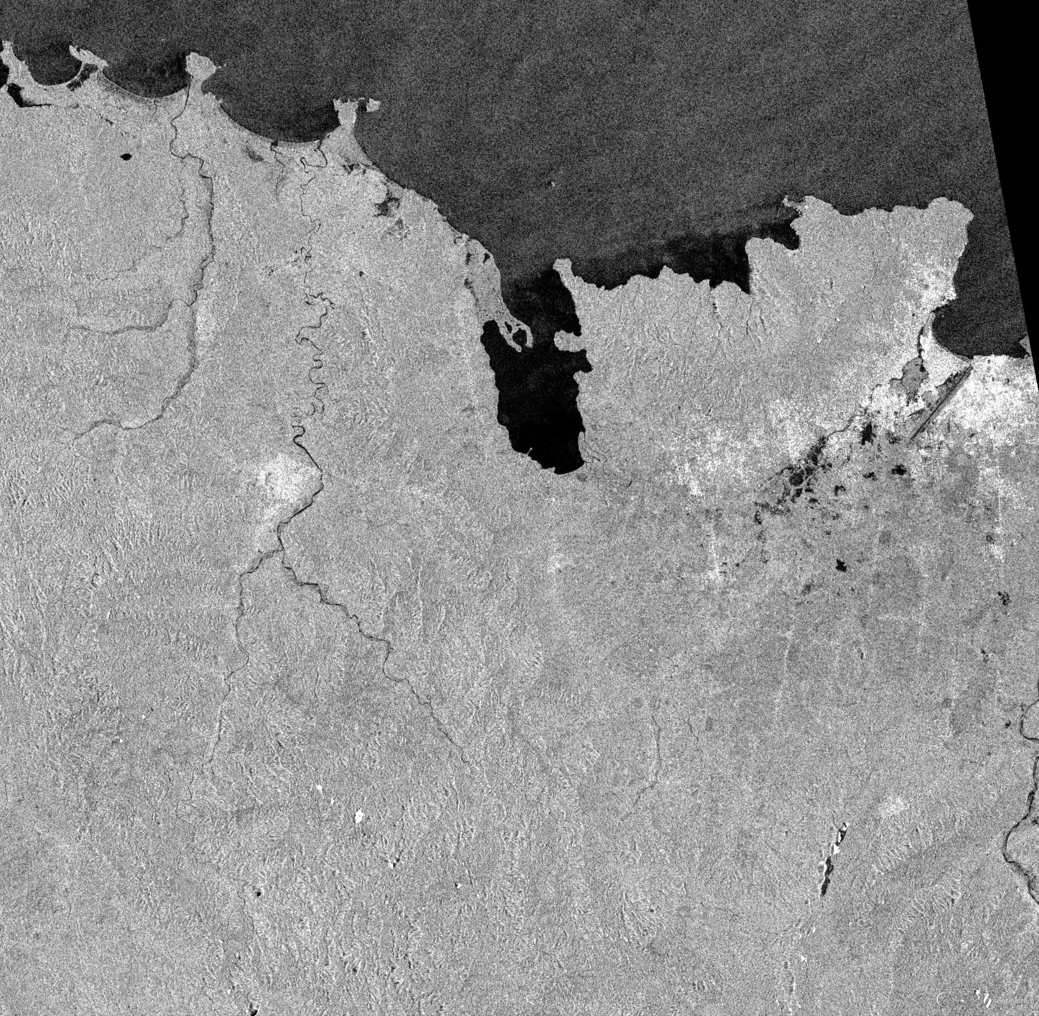

**Names**: Jakko-Jan van Ek, Julia Sipkema, Mark Boeve, Niels Verouden & Raimon Bach Pareja

**Commissioner**: S.M.J. Arts, Ministerie van Defensie

**Coach**: Sytze de Bruin

Contents

1. Folder structure 3

2. Get data 4

2.1 EO Learn API 4

2.2 EO Browser 5

2.2.1 Sentinel-1 SAR 5

2.2.2 Sentinel-1 DEM 7

2.3 Human Settlement 8

2.4 Global Surface water 9

2.5 Daily precipitation 9

2.6 Built-up surface 9

3. Creating training polygons 10

4. Running the model 13

References 14

# 1. Folder structure

Before running the model, all the folders and files needed by the model should be in the correct location. This structure is not mandatory, but recommended as the scripts are based on this structure and will not be able to find the correct files if the structure of folder names are different. When the structure is altered or names are different, the script needs to be altered as well.

The main folder, in which all the folders and files are stored is called “*Study_areaBegin_monthBegin_year*-*End_yearEnd_year*”. For example: “CapHaitienApril2016-May2021” which will look like:

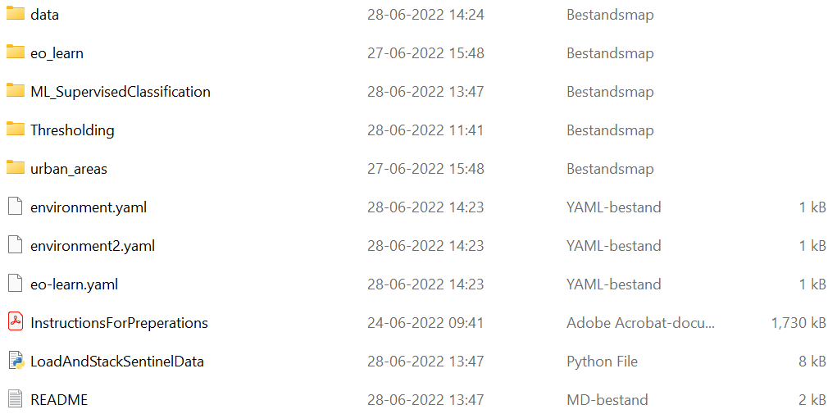  
*Figure 1: Folder structure inside main folder*

In the main folder there are five folders: ”data”, “eo_learn and “ML_SuperviserdClassification”, “Thresholding”, and “urban_areas”. In the data folder, all the input data is stored. Later in this file it will be explained how to download or get this data. The folder eo_learn is an API to download the SAR images and the other three folders are different classification methods. Further, there is a python file “LoadAndStackSentinelData” which will be used by more classification methods and is therefore placed in the main folder. This python file loads and stacks the Sentinel-1 data which is the input for the classification methods. Next, there are three .yml files with all the packages that need to be installed in order to run the parts of the model. How to add the .yml files to the environment is explained further in the README. Then, there is the README with some basic information about the model. Lastly there is information about the model which is three separate files: “InstructionsForPreperations.pdf” (this file), “ACT_Report_RGIC22-05.docx”, and “DataManagementPlan.docx”.

All the data is stored in the folder “data” and will be opened by the main and other python functions automatically, provided that all the data is stored in the correct folder and with the correct names. How the data can be downloaded will be explained in the next part of this file called ‘2. Get data’

In the data folder there should be the input folder named: “Study_areaDownloadsBegin_year-End_year”. For example: “CapHaitienDownloadsApril2016-May2021”. This folder should contain all the ZIP files with VV and VH Sentinel-1 data. This data can be downloaded from EO Browser (2022). The names of the downloaded files do not need to be changed, because the model is created to be able to read these file names Next, there should be a DEM folder containing a DEM tiff file of the study area. The folder is called “DEM'' and the name of the tiff file does not have to be changed when it is downloaded from EO Browser (2022). Further there should be a folder containing the human settlement data “GlobalHumanSettlement” and a folder containing the water dataset “WaterBodies”. These names do not have to be altered as well. At last, there is a folder called “training polygons'' with another folder called “xxxx_xx_xx” (where xxxx_xx_xx is the date (yyyy-mm-dd), for example “2020_11_02”) in which the training polygons are stored as one .shp file. This .shp file is needed to train the model, what these polygons are and how they need to be created is explained below in the section Creating training polygons.

*Figure 2: Folder structure of the data folder*

# 2. Get data

## 2.1 EO Learn API

There are two ways to download the SAR images. The most efficient way is to use the EO Learn API which will be explained here. An alternative way is to do it manually, which will be explained in the next section “2.2 EO Browser”.

EO Learn is a collection of open source Python packages that have been developed to seamlessly access and process spatio-temporal image sequences acquired by any satellite fleet in a timely and automatic manner. This script has been optimised to download SAR data (VV and VH) between two dates for a given bounding box. The VV and VH for each date are stacked, together with the VV/VH ratio and the DEM, and saved as .tif files to your directory according to the dest_name variable ('data/dest_name/___.tif'). SAR DATA is processed according to the CARD4L processing standards. More information on how to use this API can be found in the file “main_eoLearn” in the folder eo_learn.

When using the EO Learn API, several parameters should be defined in the script. In total, three parameters should be derived from your Sentinel Hub account: INSTANCE_ID, CLIENT_ID and CLIENT_SECRET. These parameters can be found on the Sentinel Hub Dashboard ([link](https://services.sentinel-hub.com/oauth/auth?client_id=30cf1d69-af7e-4f3a-997d-0643d660a478&redirect_uri=https%3A%2F%2Fapps.sentinel-hub.com%2Fdashboard%2FoauthCallback.html&scope=&response_type=token&state=%252F)). A more detailed description is given here: [link](https://www.sentinel-hub.com/develop/dashboard/)

**INSTANCE_ID**

This is the identifier of a configuration that can be set up under *Configuration Utility.* You can also just copy the ID of the configuration that is already created.

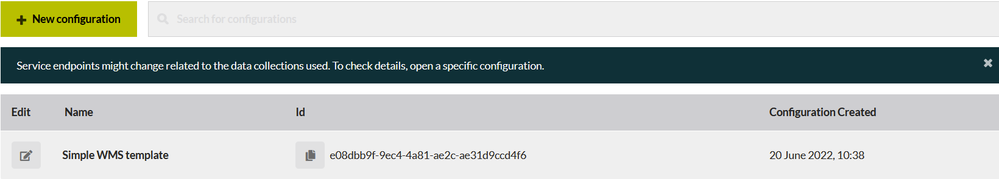

**CLIENT_SECRET**  
Click on *User Settings* and under *OAuth clients* click on *Create new*. Insert a name and click on *Create client*. Copy the CLIENT_SECRET and save it somewhere.

**CLIENT_ID**

After creating a new client, the CLIENT_ID is visible under *OAuth clients*.

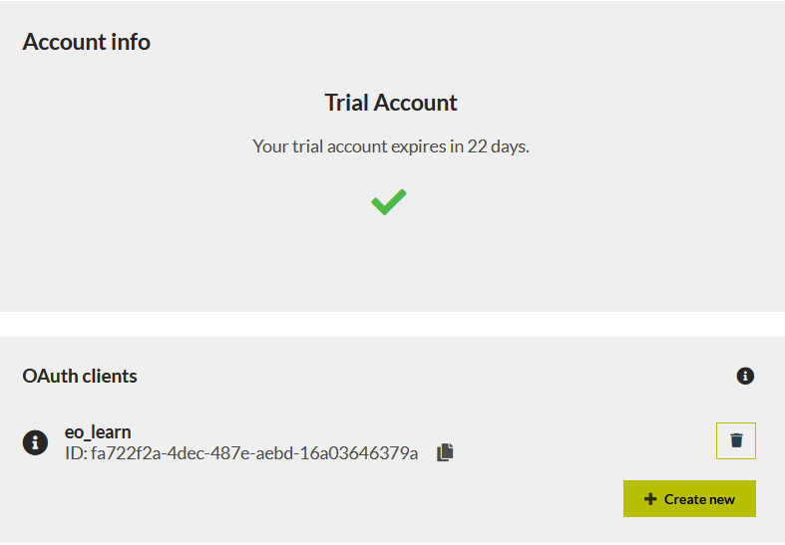

## 2.2 EO Browser

### 2.2.1 Sentinel-1 SAR

From the EO Browser the *Sentinel-1* and *DEM data* are downloaded. This is done with an easy-to-use interface. First the right study area will be searched for, the “Go to Place” search bar can be used for this (See *Figure 3*, 1). Then, a bounding box is created over the complete study area to be able to download only the selected area to save storage space (*Figure 3*, 2).

*Figure 3: Interface of EO Browser*

Next, the right date and data type is selected in the “Discover” tab. Select ‘Sentinel-1'' under the “search” tab (Figure 4). Next, select the correct begin and end date to search in a specific period (Figure 5). A lot of data from different months and years is wanted to obtain the best results from the model.

*Figure 4: Discover tab of EO Browser Figure 5: Discover tab of EO Browser (2)*

When the data is searched for, transparent polygons appear on the map. When you click on these polygons a list of datasets appear. Check the date and click on “Visualize”. Next, click on the download button on the right (*Figure* *3*, 3). Go to the “Analytical” tab and set the correct settings to download the data in the wanted form:

* **Image format:** TIFF (16-bit)
* **Coordinate system:** WGS 84 (EPSG:4326)
* **Layers:**
  + VV - decibel gamma0 - radiometric terrain corrected
  + VH - decibel gamma0 - radiometric terrain corrected

*Figure 6: Download tab of EO Browser for downloading Sentinel-1 data*

*Figure 7: Download tab of EO Browser for downloading Sentinel-1 data (2)*

When the files are downloaded, place them in correct folders according to the section *Folder structure*. Be aware that the data should be stored as a .zip file, do not unzip them.

### 2.2.2 Sentinel-1 DEM

The DEM is downloaded from EO Browser as well, using the same bounding box as with the sentinel data. Just as with the Sentinel-1, go to the “Analytical” tab and set the correct settings to download the data in the wanted form:

* **Image format**: TIFF (16-bit)
* **Coordinate system**: WGS 84 (EPSG:4326)
* **Layers**: Grayscale

*Figure 8: Download tab of EO Browser for downloading DEM data*

After the downloading is finished, place the DEM in the correct folder.

## 2.3 Human Settlement

The human settlement data is obtained from “GHSL - Global Human Settlement Layer”, provided by the European Commission (2019). This data visualises on a map how much people live in a specific area, which is useful for evaluating danger and risks of floods on a global scale. The following settings need to be set to receive the right data:

* **Product**: GHS-POP
* **Epoch**: 2015
* **Resolution**: 9 arcsec
* **Coord. system**: WGS84

You can set these settings on the left side of the screen. After setting the right settings, click on the tile on the map you want to download and the download starts immediately.

*Figure 9: Interface of the Global Human Settlement Layer website*

When the download is finished, place the .zip file in the correct folder: see section *Folder structure*.

## 2.4 Global Surface water

In the model, water bodies are masked out to prevent that water bodies are classified as frequently flooded areas. The global water data is provided by the European Commission’s Joint Research Centre (2022 and is accessible via this [link](https://global-surface-water.appspot.com/download). For downloading the data, scroll to the world map consisting of tiles. Select the tile you want to download and select the link after *Occurrence*. Place this file in the correct folder, see section *Folder structure*.

*Figure 10: Interface of the Global Surface Water Date website*

## 2.5 Daily precipitation

The precipitation data is downloaded with the “main_precipDownload” script. This script downloads daily climate data with the POWER API provided by NASA. The Application Programming Interfaces (API) allows temporal data requests of POWER Analysis Ready Data (ARD), which is in this script set to daily climate data. The daily precipitation data is exported to the main ‘data’ folder as a .csv file.

## 2.6 Built-up surface

For the urban flood detection with SAR and precipitation data, the GHS-built layer from the Global Human Settlement website is necessary ([link](https://ghsl.jrc.ec.europa.eu/download.php?ds=bu)). This dataset highlights urban areas per tile, which is required so the SAR data can be clipped to the urban extent. The following settings need to be set to receive the correct data:

* **Product**: GHS-BUILT
* **Epoch**: 2018
* **Resolution**: 30m
* **Coord. system:** Mollweide

When downloading the relevant raster tile for your area of interest, only the .tif file should be placed inside the ‘data’ folder. The name of the relevant .tif file should then be specified in the “main_urbanSAR.py” script to load the raster and clip the SAR values with the urban areas as extent.

It is worth mentioning that this website is at the time of writing under construction. Hence, the website and some settings may differ, as well as the available datasets. Nonetheless, a raster file where urban areas are highlighted should be used to run the aforementioned script.

# 3. Creating training polygons

The machine learning models need training data to know which areas are flooded and which areas stay dry. For training the data, there are polygons needed which are classified as “Flooded”, “UrbanFlooded”, and “Dry”. The creation of these polygons is done in ArcGIS Pro, because the selection and creation of polygons need visual assessment.

The first step is to find a date in which the study area is flooded. Next, the Sentinel-1 data is downloaded from that data, or just after, and just before that data. First, it is important to set the environment to the same CRS: WGS 84. In the Geoprocessing tab, search for “Environment” and set the output Coordinate System to GCS_WGS_1984 (Analysis 🡪 Geoprocessing 🡪 Environment (*Figure 11*).

*Figure 11: Setting environment CRS to GCS_WGS_1984*

Next the .TIFF files are loaded in ArcGIS: one before and one after the flood. To switch between the two files floods can be recognized in relation to the knowledge about the environment, for example where the cities are. When a flood is recognized, a polygon needs to be laid upon the specific area.

The first step for this is to add a feature class: Catalog 🡪 Databases 🡪 *Select the project with right mouse click* 🡪 New 🡪 Feature class. Give the feature class a name: *Train_Polys*. When this class is created, the name needs to be changed to *Train_Polys_xxxx_xx_*xx, with the date on the x’s. This cannot be done while creating the feature class, because ArcGIS Pro does not accept numbers in this field. The polygon are then created by going to the edit tab and draw polygons and add them to the class: Edit 🡪 Features 🡪 Create (*Figure 12*, 1)🡪 Select the Train_Polys_xxxx_xx_xx feature class 🡪 Draw polygons (*Figure 12*, 2). Select multiple areas of all three classes: “Flooded”, “FloodedUrban”, and “Dry”.

*Figure 12: Creating polygons*

After the polygons are created, search “Add field” in the Geoprocessing tab. Use the created feature class, Train_Polys_xxxx_xx_xx, as input. For the Field Name enter “Label”, set the Field Type to “Text” and press Run (*Figure 13*).

*Figure 13: Add field tool in ArcGIS Pro*

After adding the field “Label” to the training polygons, go to the attribute table (Right-click on the training polygon’s name in the Contents pane and select *Attribute table* (*Figure 12*, 3). In the Attribute table, select one of the polygons (*click on a number on the left side of the attribute table, Figure 14*, 1). As you can see, a polygon now has a light-blue edge, because it is selected (*Figure 14*, 2). Now by turning the training polygons off and on, you can see whether the area underneath the polygon is “Flooded”, “FloodedUrban”, or “Dry” (*Uncheck and check the boxes, Figure 12*, 4). Classify the polygons in the Label field by just typing “Flooded”, “FloodedUrban”, or “Dry” (Double click on a value field, *Figure 14, 3)*. When all the polygons are classified click on “clear” to clear the selection, otherwise only the selected polygon will be saved (*Figure 14*, 4).

*Figure 14: Classifying polygons*

When the polygons are classified, they need to be exported to be able to open them in python. This can be done by right-mouse clicking on the feature class in the Contents pane and select data 🡪 export features (*Figure 12*, 3). Fill in the fields as follows:

* **Input Features**: select the training polygon class from the drop down menu
* **Output Location**: select the folder wherein the polygon data needs to be stored according to the section *Folder structure*, for example:
  + CapHaitienDownloadsApril2016-May2021\2020_11_02
* **Output Name**: TrainPolys_xxxx_xx_xx, for example TrainPolys_2020_11_02

*Figure 15: Export features function in ArcGIS Pro*

After this is filled in, press “Ok”

# 4. Running the model

In order to run the model, the right data should be downloaded and placed in the right folder. When this is done, the file “LoadAndStackSentinelData.py” should be executed to pre-process the data. After this, one of the different methods can be executed by opening the main and run it. All the different methods have a specific main, placed in the folder which is called after the method. The image differencing method is placed in the machine learning folder. Further instructions and explanations are in the main and subscripts.

# References

EO Browser (2022). EO Browser, Home, Explore, derived from,

<https://www.sentinel-hub.com/explore/eobrowser/>

European Commission (2019). GHSL - Global Human Settlement Layer, Download the data produced

by the GHSL, <https://ghsl.jrc.ec.europa.eu/download.php?ds=pop>

European Commission’s Joint Research Centre (2022). Global Surface Water - Data Access, Individual

10°x10° files, derived at 29-06-2022, from <https://global-surface-water.appspot.com/download>